Day 8 coding assessment
Name: Arpit Mahalle

Output of User Story 1:
Authors:
Example Query | Purpose | Field(s) Involved
db.authors.find({ name: "J.K. Rowling" }) | Lookup by name | name
db.authors.find({ nationality: "British" }) | Filter by nationality | nationality
db.authors.find({ birthYear: { $lt: 1950 } }) | Older authors (less frequent) | birthYear
Frequently queried fields from “Authors” collection.: name, nationality
Books:
Example Query | Purpose | Field(s) Involved
db.books.find({ genre: "Fantasy" }) | Filter books by genre | genre
db.books.find({ authorId: 1 }) | Find all books by an author | authorId
db.books.find({ "ratings.score": { $gte: 4.5 } }) | Get highly-rated books | ratings.score
db.books.find({ publicationYear: 1998 }) | Filter by year (less frequent) | publicationYear

Frequently queried fields from “Books” collection: genre, authorId, ratings.score
Users:
Example Query | Purpose | Field(s) Involved
db.users.find({ email: "shyam@example.com" }) | Login or lookup by email | email
db.users.find({ joinDate: { $gte: ISODate("2023-01-01") } }) | Filter by join date (less frequent) | joinDate

Frequently queried fields from “Users” collection: email.
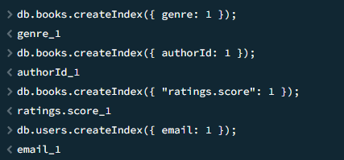
Index is created on these fields.

Queries:
db.books.dropIndex({ "ratings.score": 1 })
db.books.getIndexes()
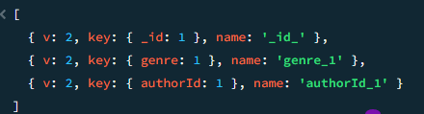
ratings.score Index is dropped and the remaining fields are displayed.
User story 2 output:
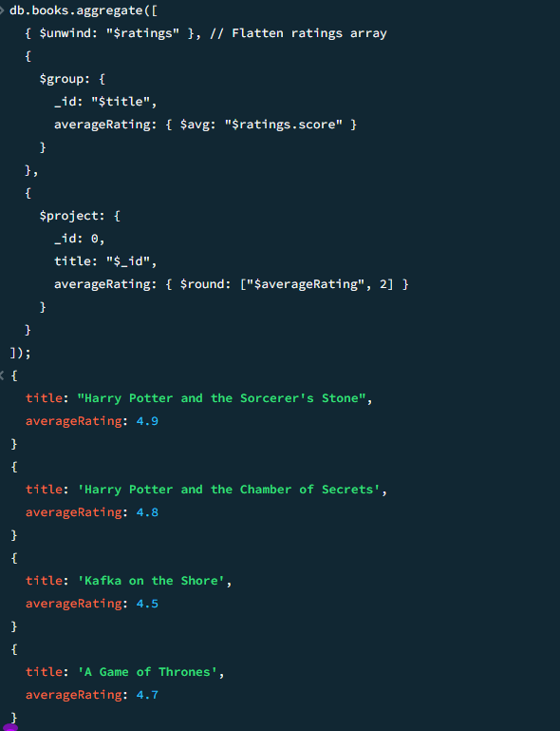

Calculating the average rating per book using $unwind, $group, and $avg.

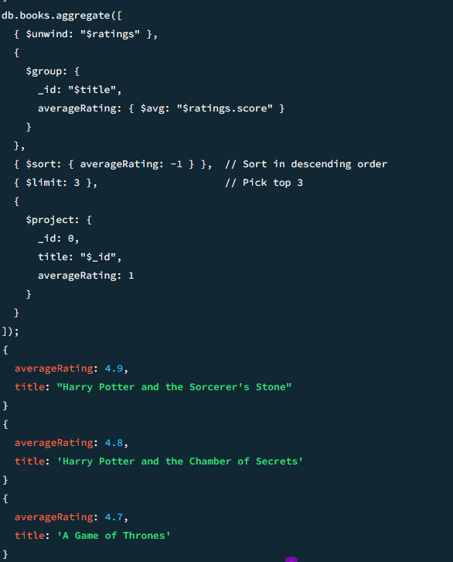

Retrieving the top 3 highest-rated books.

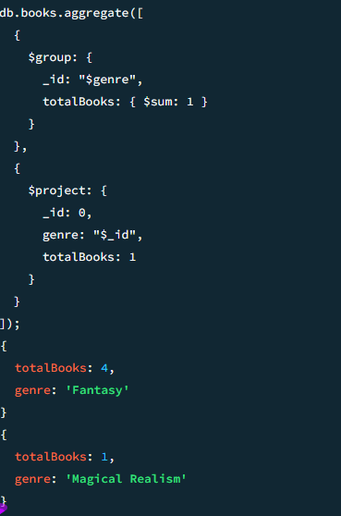

Counting the number of books published per genre.

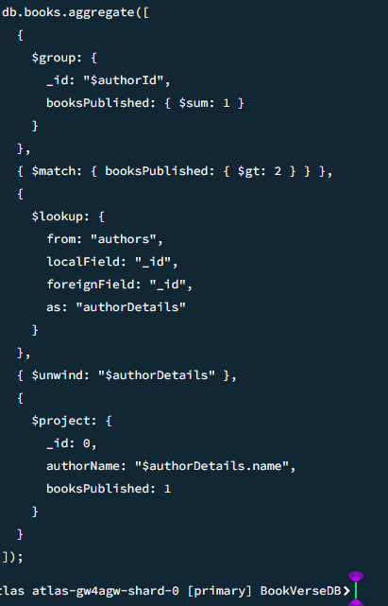

Find authors who have more than 2 books published: The output is empty because no author has more than2 books published.

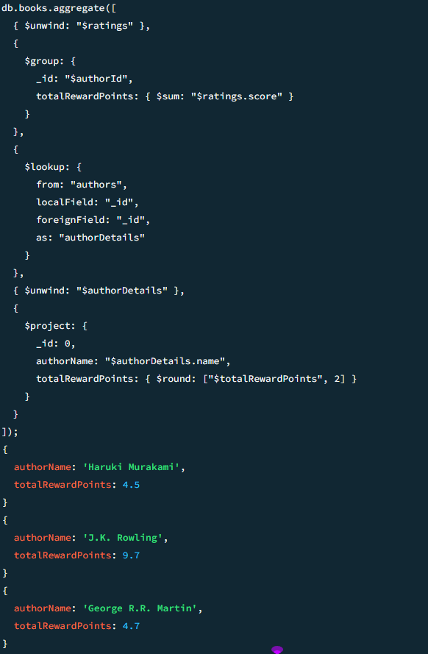

Displaying the total reward points (sum of all ratings) received by each author.

User Story 3 output:
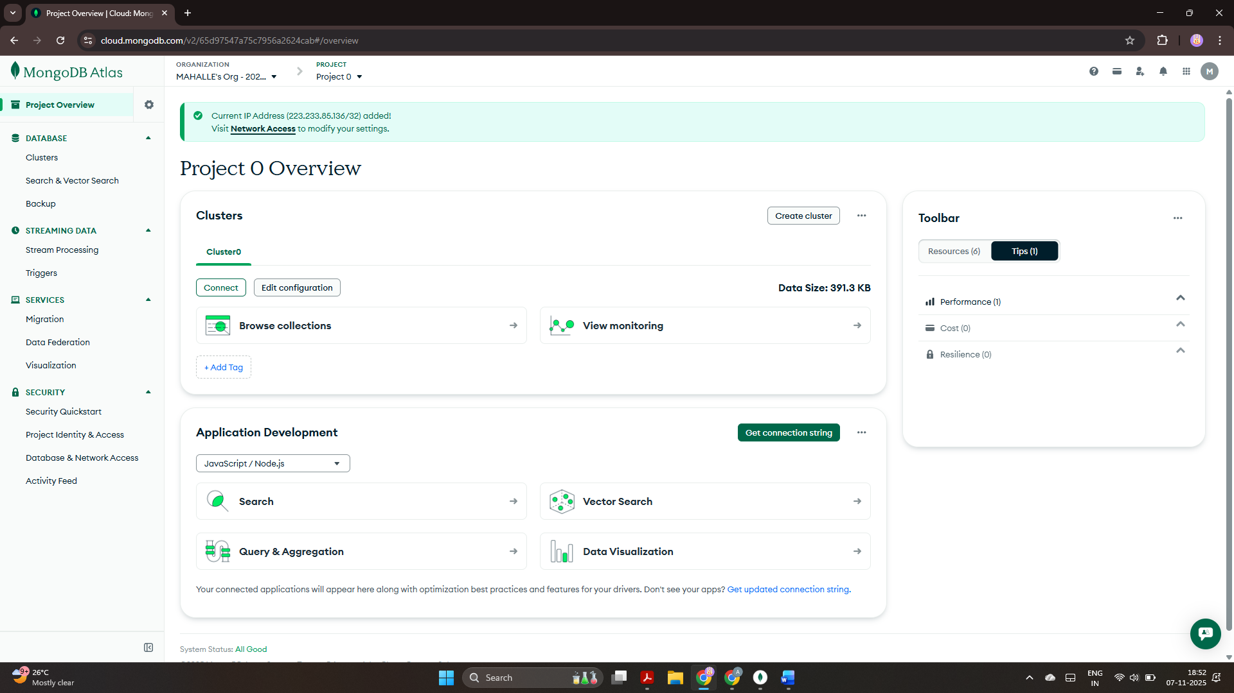

Free cluster is created. The name of the cluster is “Cluster0”.

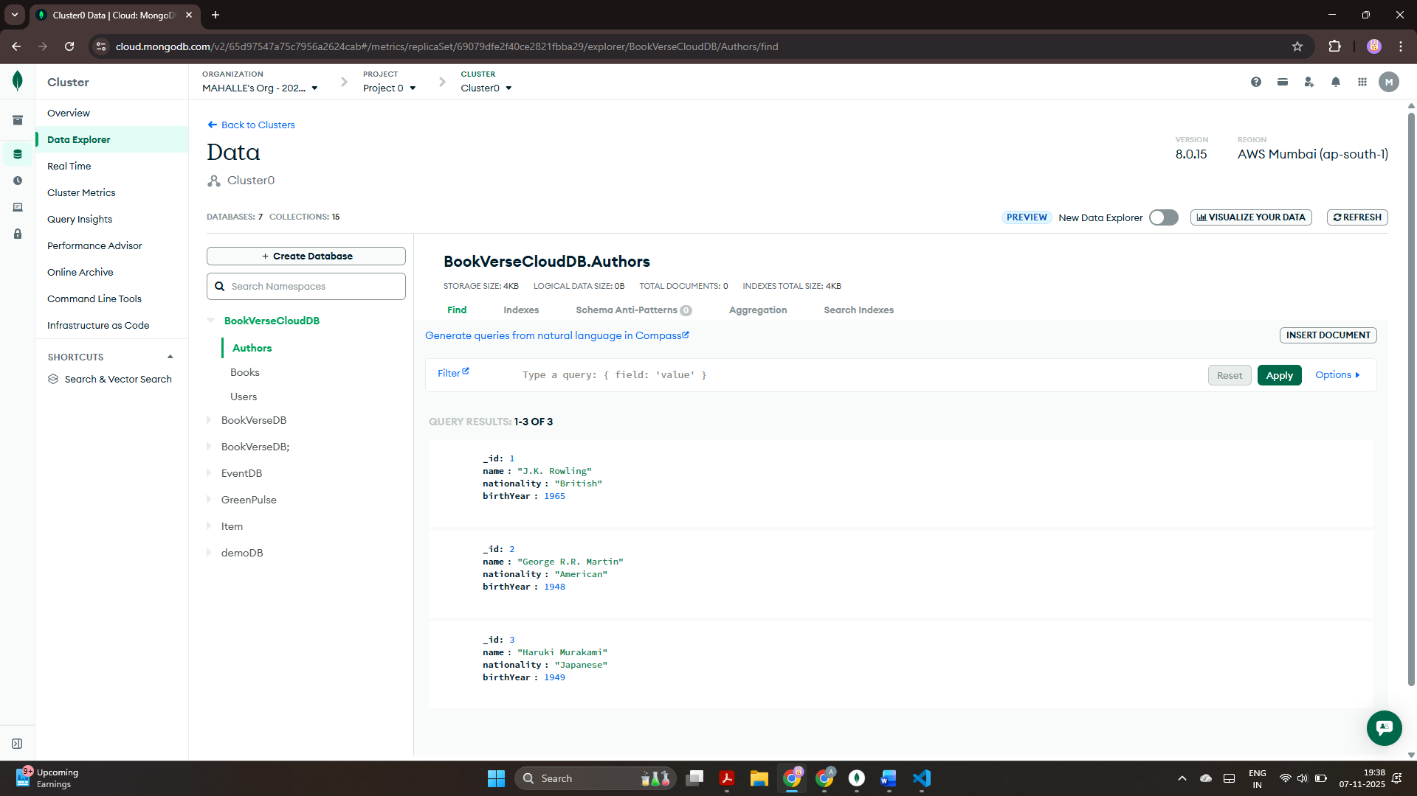

Data in “Authors” collection is inserted.

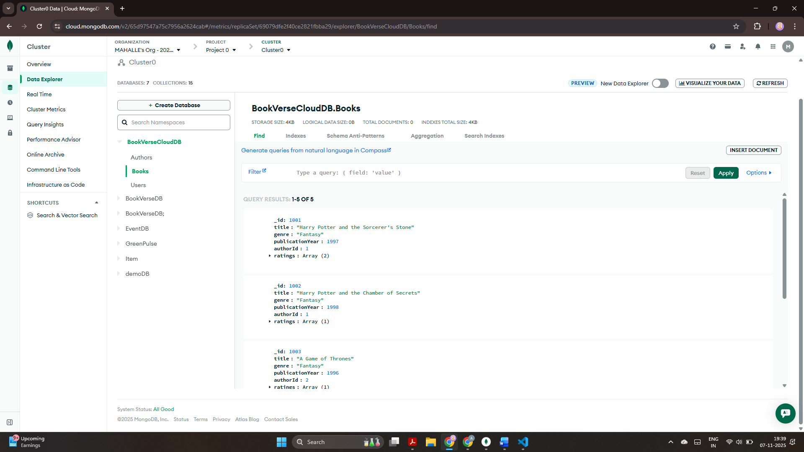

Data in “Books” collection is inserted.

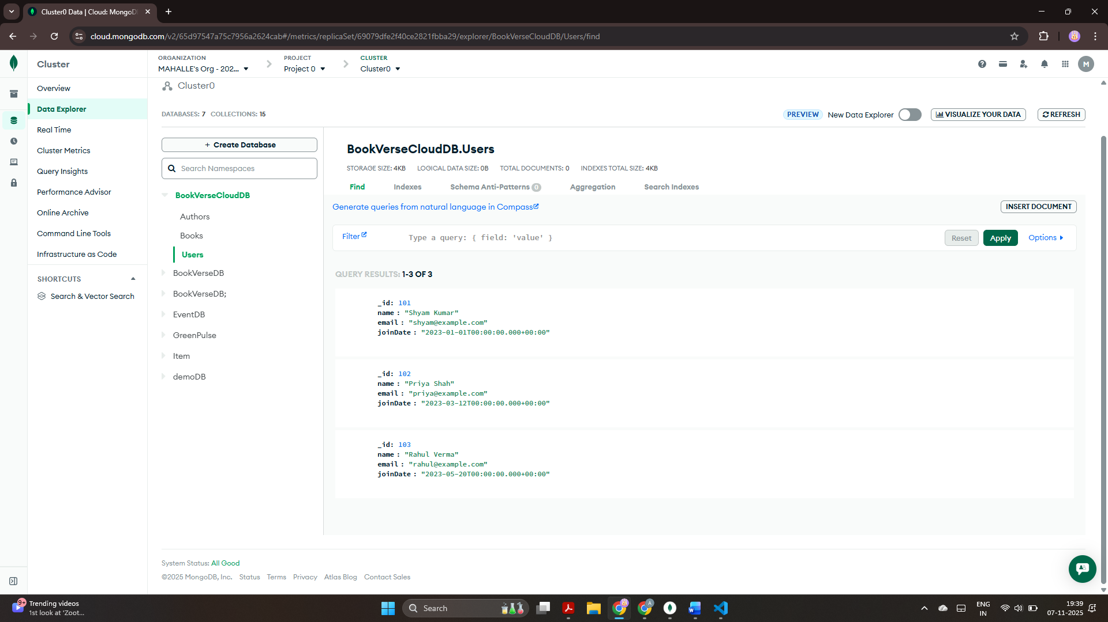

Data in “Users” collection is inserted.
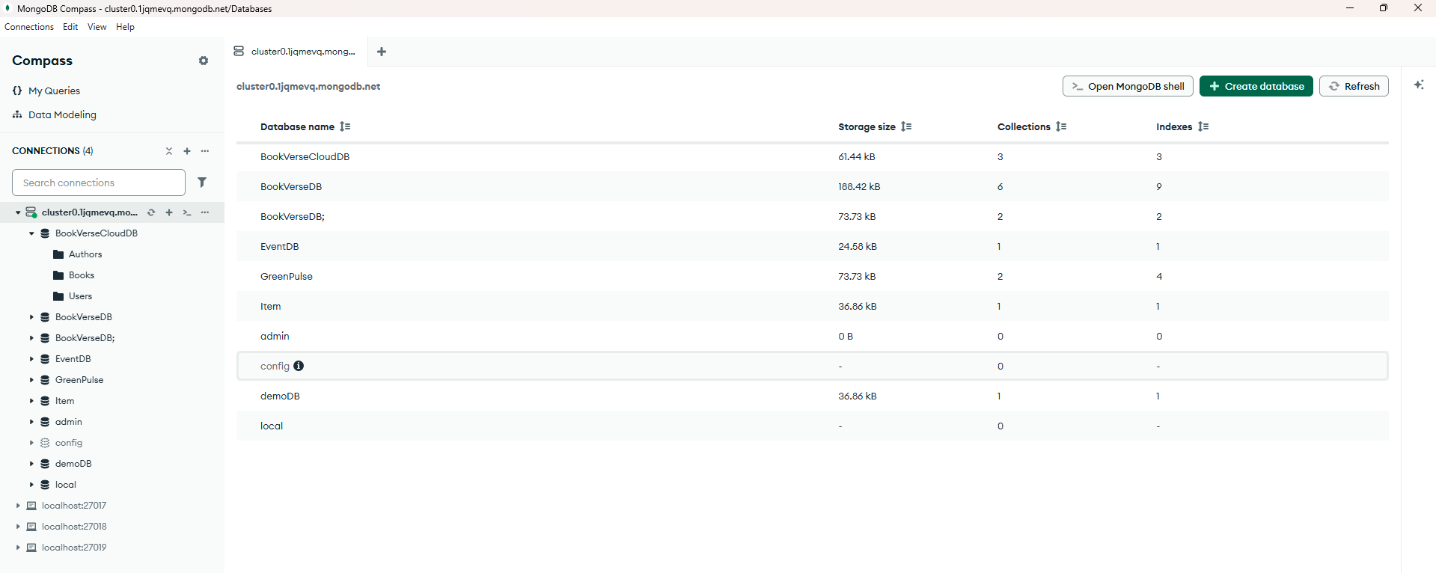

Connected my cluster using the connection string in MongoDB Compass.

